

**Job Advert**

Ref No:2021/04

Lunchtime Supervisor

Required for November 2021

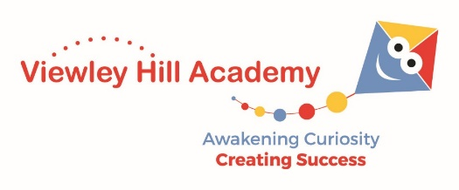Andover Way

Middlesbrough

TS89HL

**Tel:** 01642 591053

**Email:** [office@viewleyhill.org.uk](mailto:office@viewleyhill.org.uk)

[www.viewleyhillacademy.co.uk](http://www.viewleyhillacademy.co.uk)

**Head Teacher:** Mrs K Barkley

**Viewley Hill Academy**

**Lunchtime Supervisor**

**Grade:**

NJC Point 3

**Salary**

£2102.23 (Actual salary)

**Hours and Working Pattern**

Term Time Only

Contracted Hours: 5hrs per week

Viewley Hill Academy is looking to appoint a caring, enthusiastic, conscientious and self-motivated person who would like to provide a key role in supporting our children over the lunchtime period.

We are looking for a well-motivated person to supervise our children at lunchtime, actively engage them in positive play experiences and maintain high standards of behavior and safeguarding. We are very proud of our school and so we especially want someone who will really care for our children and become a positive member of our school community.

**We are looking for someone who:**

* Has excellent interpersonal skills, dedication and commitment to the care and safeguarding of our children.
* Be a role model to children, engaging and encouraging them to be their very best.
* Be a hands-on individual who can develop and implement systems/procedures as well as maintain current ones.
* Will be involved, and be part of the whole school community

**We can offer you**:

* Welcoming, friendly, dedicated and supportive staff
* A committed and forward-thinking team that put the children at the centre of school improvement
* An excellent learning environment and a strong community ethos
* A leadership team who are committed to professional development

**Visits:**

Visits to Viewley Hill are welcomed and can be arranged through the school office on 01642 591053 or via office@viewleyhill.org.uk

**Disclosure:**

Viewley Hill Academy is committed to safeguarding and promoting the welfare of children and young people and expects all staff and volunteers to share this commitment. Safer recruitment practice and pre-employment checks will be undertaken before any appointment is confirmed.  This post is subject to DBS Clearance.

**Application Process:**

Application forms are available from, and should be returned to, the academy. This can be by email , post or hand delivered. Applications should be accompanied by a covering letter and addressed to the head teacher. Please telephone the office or email [office@viewleyhill.org.uk](mailto:office@viewleyhill.org.uk) for any further detail.

Alternatively, forms can be downloaded from our website. [www.viewleyhillacademy.co.uk](http://www.viewleyhillacademy.co.uk)

**Application Timeline:**

Closing Date: Thursday 14th October 12 noon

Shortlisting: Friday 15th October 2021

Interviews: Tuesday 19th October 2021